**Azure function- Jfrog local library integration  
  
Step 1: Set Up JFrog Artifactory**

1. **Create an Account**:
   * If you don’t have a JFrog Artifactory account, sign up for one at the JFrog website.
2. **Install JFrog Artifactory**:
   * You can choose to host it on-premises or use JFrog's cloud service. Follow the installation instructions based on your choice.
3. **Create a Local Repository**:
   * Log in to your Artifactory instance.
   * Navigate to the “Admin” section.
   * Under "Repositories," select "Local."
   * Click on "Add Local Repository."
   * Fill in the repository details (name, package type, etc.) and save it.

**Step 2: Set Up Azure Functions**

1. **Create an Azure Function**:
   * Log in to the Azure Portal.
   * Click on “Create a resource” and select “Function App.”
   * Fill in the required details (subscription, resource group, function app name, runtime stack, etc.) and create it.
2. **Choose a Development Environment**:
   * You can use Azure Portal, Visual Studio, or Visual Studio Code to develop your function.

**Step 3: Configure Your Azure Function to Use JFrog Artifactory**

1. **Set Up Authentication**:
   * Obtain your JFrog Artifactory API key or username/password for authentication.
   * Store these credentials securely. You can use Azure Key Vault or application settings in Azure.
2. **Modify Function Code to Access Artifactory**:
   * In your Azure Function code, add logic to interact with JFrog Artifactory. For example, if you are using Node.js, you can use the axios or node-fetch package to make HTTP requests.

Here’s a sample Node.js function that downloads an artifact from JFrog:  
  
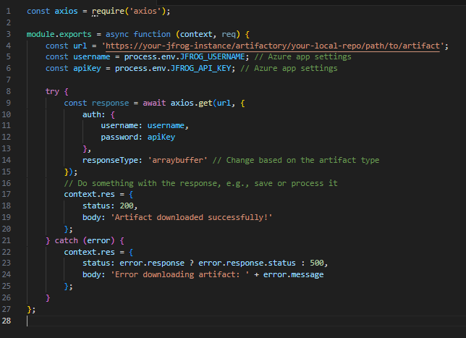

1. **Install Required Packages**:
   * If you're using Node.js, ensure that your package.json includes any libraries you need (like axios).
   * Use npm install to install dependencies locally.

**Step 4: Deploy Your Function**

1. **Deploy from Visual Studio or VS Code**:
   * If you're using Visual Studio or Visual Studio Code, use the built-in deployment tools to publish your function to Azure.
2. **Using Azure CLI**:
   * If you're using the Azure CLI, you can deploy using the following command:  
       
     

**Step 5: Test Your Azure Function**

1. **Test from the Azure Portal**:
   * Go to your function in the Azure Portal.
   * Use the "Test/Run" option to trigger the function and check the logs for success or errors.
2. **Monitor Logs**:
   * Use Application Insights (if set up) or check the logs in the Azure Portal to troubleshoot any issues.

**Step 6: Secure Your Integration**

1. **Use Azure Key Vault**:
   * Store sensitive information (like API keys) in Azure Key Vault and access it securely within your Azure Functions.
2. **Set Up Firewall Rules in JFrog**:
   * If your Azure Functions are hosted in a private network, ensure that JFrog Artifactory is accessible to the Azure Functions by configuring the necessary network and firewall settings.